English |  |  |  | Maths
Mr Men and Little Miss books  We will be reading a range of Mr Men and Little Miss books in English and in Guided Reading. We will be talking about the different characters using the clues from the texts. We will be looking at what happens in the stories and how the characters sometimes change due to events that happen. We will also be exploring the words, phrases and techniques that the author uses. We will then create our own Mr Men or Little Miss characters and write stories about them in the style of Roger Hargreaves, focusing on the following:  - Using adjectives, verbs and adverbs to describe the characters  - Identifying and writing questions, statements, commands and exclamations  - Using conjunctions (or/and/but/so/when/if/because/that) to join sentences together  - Using –ly to turn adjectives into adverbs (e.g. slow/ slowly)  Mr Men and Little Miss poems  We will be using our knowledge of the characters to write descriptive poems using a range of adjectives.  Read Write Inc  The children who are taking part in the RWI programme will be reading and writing about a range of books across the half term. See the weekly ‘home’ books for the green and red words to practise. |  |  |  | Number and place value – counting in steps of 2, 3, 5 and 10  Addition and subtraction – number facts to 20; inverse operation; problem solving; adding three one-digit numbers; adding two-digit numbers and ones; adding two-digit numbers and tens; doubles and halves of numbers up to 20.  Multiplication and division – solving problems using multiplication facts for the 2, 5 and 10 multiplication tables; use the multiplication (x) and equals (=) signs; show that multiplication of two numbers can be done in any order (commutative); solve problems involving multiplication and division, using materials, arrays, repeated addition and mental methods.
Science |  | Year 2 Sycamore Class Topic Web  Spring 1 2018 |  |  | Art and Design
Animals, including humans  We will be finding out about and describing the basic needs of animals, including humans, for survival (water, food and air), describing the importance for humans of exercise, eating the right amounts of different types of food, and hygiene, and noticing that animals, including humans, have offspring which grow into adults. We will also be learning about food chains. |  |  |  |  | Moving pictures  We will be evaluating and analysing moving picture books with slides, levers, dials etc… before designing and making our own moving pictures based on the Mr Men and Little Miss characters.
 |  | 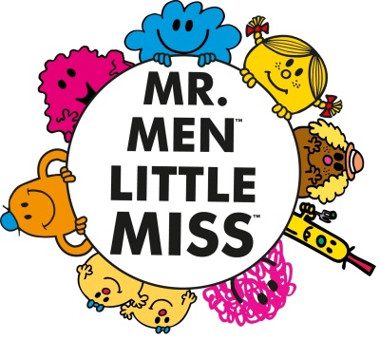
PSHE | PE |  | RE | Computing |  | Music
Relationships  We will be exploring, discussing and celebrating relationships. | We will continue to work with the sports coach. |  | Remembering / Passover  We will be thinking about what and how we remember events, people and stories, before thinking about how Christians remember Jesus at Christmas and how Jewish people remember God’s help at Passover. | Coding  We will be learning how to create simple computer programs using coding. |  | The long and the short of it  We will be exploring duration in musical pieces and when using instruments.

