English |  |  | Maths
Read Write Inc  All Year 1 children are taking part in the RWI programme and will be reading and writing about a range of books across the half term. See the weekly ‘home’ books for the green and red words to practise. |  |  | Number:Addition and subtraction  Represent and use number bonds and related subtraction facts to 20  Read, write and interpret mathematical statements involving addition(+) and subtraction (-) and equals (=) signs  Add and subtract one and two-digit numbers to 20, including zero  Solve one step problems that involve addition and subtraction, using concrete objects and pictorial representations and ‘missing number’ problems.  Measurement:Length and Height  Measure and begin to record lengths and heights  Compare, describe and solve problems for length; lengths and heights eg long/short, longer/shorter, tall/short, double/half
Science |  | Willow Class Topic Web  Spring 1 2018 |  |  | Art and Design
Finding facts about the Sun  Sun Safety - designing a Poster  Exploring shadows and how they change  Naming and describing the seasons  Describing the weather – Making a weather chart |  |  |  |  | We will be using a range of media to create artwork based around our weather and seasons topic including Northern Lights collages and Four Seasons Tree 3D Books.
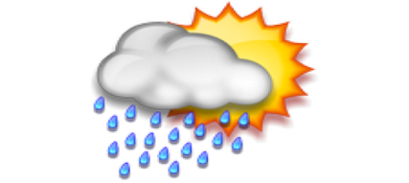
Weather and Seasons

PSHE | PE | RE |  | Geography |  | Music
Relationships  We will be exploring, discussing and celebrating relationships. | We will continue to work with the sports coach. | Remembering / Passover  We will be thinking about what and how we remember events, people and stories, before thinking about how Christians remember Jesus at Christmas and how Jewish people remember God’s help at Passover. |  | Weather Patterns  Seasonal Changes in Weather  Extreme Weather Conditions  Weather and Animals in Cold Climates  Weather and Animals in Hot Climates |  | The long and the short of it  We will be exploring duration in musical pieces and when using instruments.

