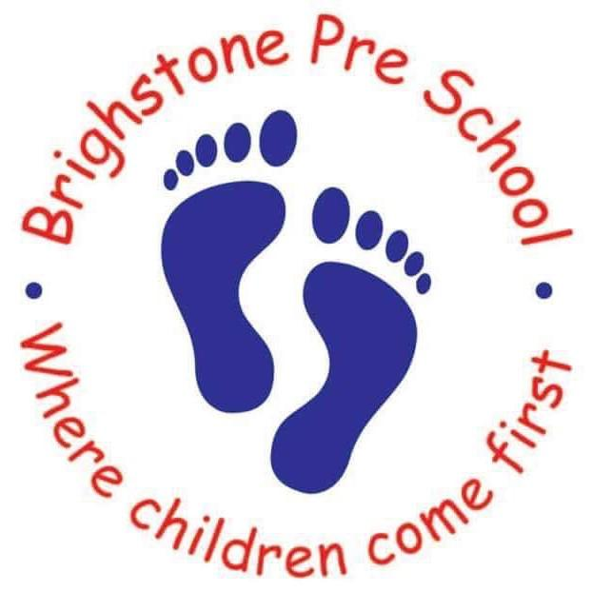

Brighstone Preschool will be open for childcare during half term (12th-16th Feb)
We will be open Monday – Friday at our Brighstone Preschool for children aged 2-11 inclusive.
Our opening times will be 7.30am – 5pm.
Our charges will be £5 per hour for the first child and £4.50 for any subsequent child/ren.
You will need to book your child/ren in by Friday 26th January.
Limited spaces available.

If you have any questions please contact Brighstone Preschool on 07707319843

------------------------------------------------------------------------------------

February ½ Term 2018

If you wish your child to attend the Holiday Club held at Brighstone Preschool, please fill in the form below with days and times required. Our opening hours are 7.30am-5pm and the cost is £5 an hour for the first child and £4.50 for any subsequent children.

week beginning  12th February | Monday | Tuesday | Wednesday | Thursday | Friday | Number of hours
Times

1. Child Name................................................................. DOB…………………….
2. Child Name................................................................ DOB…………………….
3. Child Name................................................................ DOB…………………….

Parent or Carers Name:................................................................
Contact No:.................................................................................
Signed..................................................................

You will be required to complete a registration form with all your contact details and your child's details upon booking.

Many Thanks
Jayne Hill
Manger Of Niton and Brigshtone Preschool.

