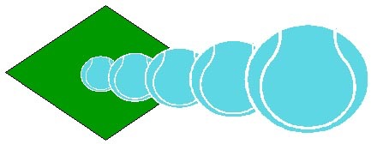

**10.00am - 11.30am**

**Players Aged 5yrs - 16yrs (age groups split)**

All abilities welcome, all equipment provided, fun games and activities, LTA qualified Coach and tennis leaders

**Cost:** 3 days £18.00 per person (members) £20.00 per person non member

1 day sessions available on request

TO BOOK OR for further information contact Club Coach

Nick Searles on O7780932704 or email nicksearles10@yahoo.co.uk

Spaces limited so please book early

Follow us on Facebook or on our web site

www.clubspark.lta.org.uk/RydeMeadLawnTennisClub

Refreshments available at Courtside Cafe in our Clubhouse

**Course Details**

**Course 1 Monday 24th, Tuesday 25th Wednesday 26th July**

**Course 2 Monday 31st, Tuesday August 1st, Wednesday 2nd**

**Course 3 Monday 7th, Tuesday 8th, Wednesday 9th August**

**Course 4 Monday 14th, Tuesday 15th, Wednesday 16th August**

RYDE MEAD TENNIS CLUB SUMMER HOLIDAY CAMPS 2017