Literacy |  |  | Maths
Using the Following Treasure Island Moonfleet Smugglers Song  Written Outcomes:  A diary extract, written in character  A piece of narrative writing  A class/group debate  A non-fiction text about pirates  A character study based on Pirates from Treasure Island  Reading Outcomes:  Over the course of the unit pupils will be given many opportunities to:  Develop positive attitudes to reading by increasing their familiarity of fiction from the English literary heritage. Discuss similar themes occurring across stories and expressing preferences Draw inferences such as inferring characters' feelings, thoughts and motives from their actions Predict what might happen from details stated and implied in the text. |  |  | Place value in 4-digit numbers : Cand order numbers up to 1000 identify, represent and estimate numbers using different representations read and write numbers up to 1000 in numerals and in words.  Addition and subtraction : add and subtract numbers mentally, including: a three-digit number and ones a three-digit number and tens a three-digit number and hundreds add and subtract numbers with up to three digits, using formal written methods of columnar addition and subtraction estimate the answer to a calculation and use inverse operations to check answers solve problems, including missing number problems, using number facts, place value, and more complex addition and subtraction.  Multiplication and division ; recall and use multiplication and division facts for the 3, 4 and 8 multiplication tables  write and calculate mathematical statements for multiplication and division using the multiplication tables that they know, including for two-digit numbers times one-digit numbers, using mental and progressing to formal written methods solve problems, including missing number problems, involving multiplication and division, including integer scaling problems and correspondence problems in which n objects are connected to m objects.  Division and fractions : count up and down in tenths; recognise that tenths arise from dividing an object into 10 equal parts and in dividing one-digit numbers or quantities by 10  ▪ recognise, find and write fractions of a discrete set of objects: unit fractions and non-unit fractions with small denominators recognise and use fractions as numbers: unit fractions and non-unit fractions with small denominators recognise and show, using diagrams, equivalent fractions with small denominators add and subtract fractions with the same denominator within one whole (e.g. 5/7 + 1/7 = 6/7) compare and order unit fractions, and fractions with the same denominators solve problems that involve all of the above.  Shape and Data: draw 2-D shapes and make 3-D shapes using modelling materials; recognise 3-D shapes in different orientations and describe them recognise angles as a property of shape or a description of a turn identify right angles, recognise that two right angles make a half-turn, three make three quarters of a turn and four a complete turn; identify whether angles are greater than or less than a right angle identify horizontal and vertical lines and pairs of perpendicular and parallel lines. interpret and present data using bar charts, pictograms and tables  ▪ solve one-step and two-step questions such as ‘How many more?’ and ‘How many fewer?’ using information presented in scaled bar charts and pictograms and tables
Science |  | Year 3 Swallows Class Topic Web  Summer Term 2 2017 |  |  |  | History/Geography
This half term we are focusing on animals, including humans, and looking at our skeletons and muscles specifically. We will carry out investigation work about how our bodies respond to exercise and the children will carry out their own fair tests. We will also focus on differences between individuals and challenging stereotypes held. |  |  |  |  |  | Investigate: Real Life Pirates Curriculum links ‐ Social Subjects – People, Past Events & Societies  Children will find out more about the infamous real life pirates such as Calico Jack Rackham, Blackbeard, Captain Kidd, Henry Every and female pirate Anne Bonny. They will discover how our coastline was a haven for Smugglers. Link to History of Brighstone.  In geography they use maps to plot the coastline of the Isle of Wight and use compass directions and coordinates for treasure maps.
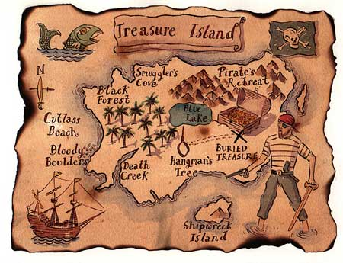
Smugglers Scoundrels and Scallywags
RE | Art | PHSE |  | FRENCH | Design | PE | Music
Protection  Raksha  Bandhan | Clay tiles and clay pottery based on seascapes. | Going for goals, setting targets and personal development of moving on. |  | We will be continuing to think about our life in school, including vocabulary we might use in a PE lesson, and then moving on to food, glorious food! Here we will express preferences about what we like and dislike. | Build a raft/boat using design and construction skills. | Athletics and dancing | Mr Stroud will introduce and teach children brass instruments. Trumpet and cornet.  Sea shanties and songs for Carousing! originated on ships from many different countries, and they spread throughout the sea‐faring world. Shanties were used for the hard work aboard ships and sentiments in them were universal. They were not originally in the musical form we find them today, but chanted ‐ with the chanter calling out words and the men calling out the chorus in rhythm to their work

