Literacy |  |  |  | Numeracy
In literacy, this half term, we will be looking at letters (description) and retelling of a narrative whilst examining the picture book The Arrival by Shaun Tan.  Letter  Students will write a letter describing a new country to their family back home.  Narrative  The pupils will retell portions of the story of The Arrival.  SPAG  The children will be exploring a variety of SPAG activities concentrating on the use of describing words (adjectives, adverbs, phrases and clauses) as well as dialogue.  Reading – We will be reading After Tomorrow as a class reader in our guided reading lessons. |  |  |  | In numeracy, this half term, we will be learning about:  Calculations: to add, subtract, multiply and divide decimals by whole numbers and by other decimals.  Fractions: learning to add, subtract, reduce and compare fractions and decimals (with some work on percentages)  Measurements – converting metric units and solving problems involving measurements
Science |  | Kingfisher Class Topic Web  Spring 2 2017 |  |  |  | History/ Geography
In science, this half term, we will be looking at the human body concentrating on healthy eating, the digestive system, the nervous system and the circulatory system. |  |  |  |  |  | We will look at countries and capital cities of Europe as well as exploring various changes in human population.
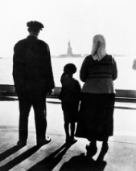
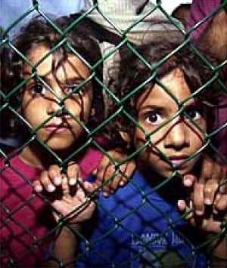
Immigration and Refugees
RE | PSHE | French | Art/ D&T |  | PE | Computing | Music
We will be looking at Jesus’ death and the cross and what it means for Christians. | In PSHE this half term, we will be exploring healthy eating and we will examine the idea of refugees, concerns we have about refugees and support we can give. |  | Examining various types of ‘street art’ and junk art – attempting to create a piece of junk art ourselves. |  | Ball games  We will be learning about different ball games and how to play them and the rules behind them. | Programming by practicing creating designs, using a word program to produce a letter and creating visual displays to reinforce the core values of the school.

