Literacy |  |  |  | Numeracy
In literacy, this half term, we will be looking at script writing and will examine Shakespeare’s A Midsummer Night’s Dream as well as some of his sonnets and other poetry.  Script  The students will create a play based off of various improvisation activities with a focus on emotional literacy (being able to explain our feelings)  Poetry  The pupils will use poetry to relate and describe some of their emotions.  SPAG  The children will be exploring a variety of SPAG activities concentrating on the use of describing words (adjectives, adverbs, phrases and clauses) as well as dialogue.  Reading – We will be reading A Midsummer Night’s Dream and some poetry in our guided reading lessons. |  |  |  | In numeracy, this half term, we will be learning about:  Calculations: to add, subtract, multiply and divide decimals by whole numbers and by other decimals.  Fractions: learning to add, subtract, reduce and compare fractions and decimals (with some work on percentages)  Measurements – converting metric units and solving problems involving measurements
Science |  | Oak Class Topic Web  Autumn 1 2017 |  |  |  | History/ Geography
In science, this half term, we will be looking at light which will include how our eyes work and the colour spectrum. |  |  |  |  |  | We will look at how the Greeks influenced our civilization (government, philosophy, science and art) and will be exploring key features of the world’s continents, including being able to identify them on a map.
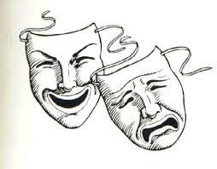
Page to Stage
RE | PSHE | French | Art/ D&T |  | PE | Computing | Music
Laws – Jesus the lawbreaker | In PSHE this half term, we will be exploring our emotions and how best to express them. |  | We will practice painting silhouettes (Greek style) and will attempt to make Greek vases. |  | Ball games  We will be learning about different ball games and how to play them and the rules behind them. | Finding things on the internet and internet safety.

