Literacy |  |  |  | Numeracy
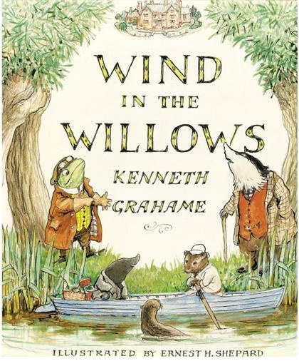  In literacy, this half term, we will be looking at:  Narrative- This term Juniper pupils will be reading the poetry of Alfred Lord Tennyson. They will be inspired by the language of the poetry to create their own piece.  Newspaper Reports- Following on from the poetry work we will be reading a classic text – Wind in the Willows. This text will be used as a basis for doing some investigative writing  SPAG  Punctuation and grammar are taught throughout all English sessions. When writing poetry the focus for grammar will be on using figurative and descriptive language, while learning to develop rhythm and imagery in poetry. Newspaper writing will see pupils working on their organizational skills and developing vocabulary for non-chronological reports.  In Juniper Class there will be two aspects to Guided Reading. Pupils who need support with their phonic and reading skills will continue to have specific Read Write Inc sessions. Additionally pupils will read Wind in the Willows during guided reading sessions and listen to audio versions of the story. |  |  |  | In numeracy, this half term, we will be learning about:  Multiplication and division: Pupils in Juniper Class need to become proficient when using times tables. The focus this half term is to be secure in 2, 5, 10, as well as learn the 3 and 4 times tables. Practise both at home and school is the only way to ensure that this happens. As with multiplication, pupils need to be secure in using their times tables in order to solve division problems.  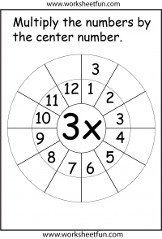  Fractions: Additionally, pupils will consolidate their knowledge of discrete sets of fractions such as, ¼, ½ ¾ and develop an understanding of tenths (1/10). They will be able to label fractions of shapes and be able to explain their reasoning. They will learn to compare and order fractions of the same denominator.  Shape, Space, Measure: Throughout the term pupils will explore Shape, Space and Measures through their scientific work and through problem solving using units of measure for length, weight and volume.
Science |  | Juniper Class Topic Web  Autumn 2 2017 |  |  |  | Geography
During this half term we will investigate rocks and soils in Science. The children be exploring why rocks are useful and thinking about which rocks our Island is made from. We will consider how the 3 main rock groups are formed and test the characteristic of different rocks. We will also be looking at how fossils are formed and will have fun producing our own replica fossils. Finally, we will be discovering what soil is composed off and will start our year-long investigation into how leaves are converted into compost. |  |  |  |  |  | We will explore the local geography of the island and look in particular at the things of interest on our door step. A visit to the Long Stone is planned where we will observe features of the landscape and use our developing geographical skills to measure, present and record information. In addition we will compare our findings in our local area to other locations. Pupils will explore the similarities and differences between birds’ eye view plans and topical plans. They will look at both human and physical geography of the local area.
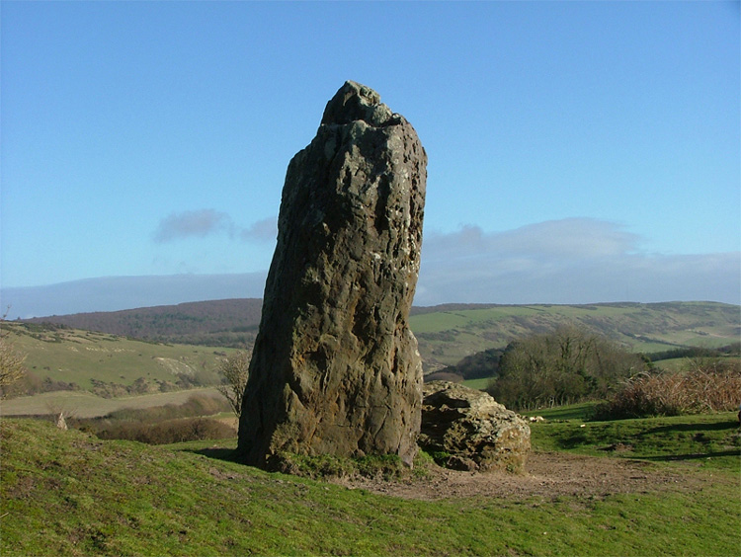
What’s Around the Corner?
RE | PSHE | French | Art |  | PE | Computing | Music
This term in Religious Education, pupils will learn how Christians worship the birth of Christ. This will include discussions about really important but difficult concepts such as the Holy Trinity. | This term the focus is on Bullying, helping pupils to develop their interpersonal skills. A key focus is how to assert themselves and make their wishes understood while maintain positive relationships with others. | In French we will continue practicing our conversational skills, asking and answering questions about ourselves, and we will learn vocabulary for colours and body parts. | Over the half term, the children will improve their sketching skills by observing and drawing the local environment, including the local landscape. Watercolour techniques will be explored as will transitory art. |  | PE coaches will be working with children this term on a variety of ball skills and games. | This term pupils will continue to learn about programing and coding. In addition they will focus on internet safety and using computers responsibly. In addition they will use Purple Mash to create spreadsheets and input data. | In Juniper the pupils will continue to have Brass lessons with Mr Stroud each Friday afternoon.

