English |  |  | Maths
Narrative  We will be watching a short animation called ‘Taking Flight’ about a little boy who goes on wonderful adventures to imaginary lands with his grandfather. We will take part in drama and role-play to re-enact these wonderful lands before playing around with language to use and make wondrous words (including adjectives and verbs to describe settings, characters and feelings). We will then write about one of the imaginary lands where they could go, using expanded noun phrases to describe the setting and the characters, and conjunctions, verbs and adverbs in creative ways.  Poetry  We will be exploring and describing scenes of winter wonderlands, using adjectives, nouns, verbs and adverbs to play around with language, including the use of rhythm and rhyme. We will read, enjoy and discuss poems about winter, snow and ice, using our senses, before creating our own winter wonderland poems. |  |  | During this second half term we will continue to focus on number and place value, and addition and subtraction, to ensure that these concepts are fully embedded and understood before we move onto fractions, and multiplication and division. We will also focus on shape.  Number and place value – counting in steps of 2 and 10; tens and units; comparing and ordering numbers up to 100, using equipment including Numicon, number lines, 100 squares, Dienes blocks (base ten), bead strings, place value arrow cards, place value counters, money etc…  Addition and subtraction – number facts to 20; inverse operation; problem solving (including the use of money); addition and subtraction of 2-digit numbers.  Shape – the names and properties of 2D and 3D shapes.
Science | Year 2 Sycamore Class Topic Web  Autumn Term 2 2017 |  |  |  | D&T
Materials and their properties  We will be exploring different materials, including wood, plastic, fabric, stone, brick, glass, paper, card, metal etc…  We will explore which materials are suitable for different purposes and why, as well as investigating how they can be changed.  We will then plan and carry out an investigation about the strength of different materials. |  |  |  |  | Wheeled toys  We will be exploring and investigating different wheeled toys – looking at how they are constructed and what the different components are (e.g. axle, axle support, chassis, wheel, body etc…). We will then design and make a wheeled vehicle that could take the little boy and his grandfather to wondrous imaginary worlds.
Wonderful Wondrous Wonderlands

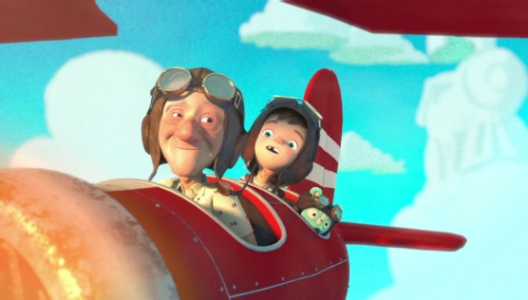
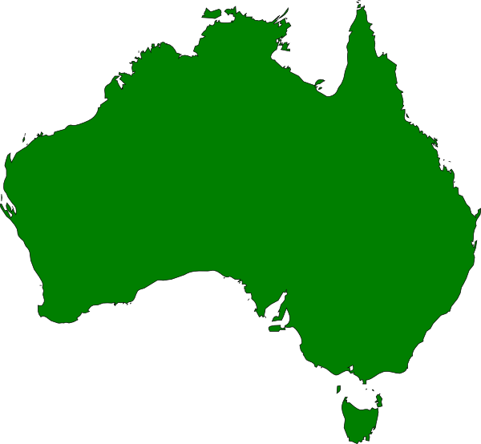

RE | Art | Computing |  | PSHE / SEAL | PE | Music
Incarnation / Celebration | Exploring and experimenting with different media to create different imaginary worlds and landscapes. | Coding – Purple Mash |  | Say No to Bullying | Sports Coach | Feel the pulse – Exploring pulse and rhythm

