English |  | Maths
Recount  Written recounts of summer holidays.  Narrative  The Scarecrow Who Didn’t Scare by Neil Griffiths – focusing on retelling the story; matching animals to actions; expanded noun phrases to describe the setting, the animals and the scarecrow; questions and statements; use of conjunctions (e.g. and/or/but); creating a class drama version of the story incorporating all of the above elements.  Narrative  Tiddalik, an Australian dreamtime story - focusing on retelling the story; expanded noun phrases to describe the setting and the animals; questions and statements; rewriting the story using their own choice of words and phrases. |  | Number and place value – counting in steps of 2 and 10; tens and units; comparing and ordering numbers.  Addition and subtraction – number facts to 20; inverse operation; problem solving.  Multiplication and division – times tables for 2 and 10; odd and even numbers.  Measurement – time; lengths, money.
Science | Year 2 Chaffinch Class Topic Web  Autumn Term 1 2016 |  | Geography
Things that are living, things that are dead and things that have never been alive.  Animals and their habitats and micro-habitats in the school grounds, the UK and Australia – how living things and their habitats are dependent on each other, and how the habitats provide for the needs of the living things that live in them. |  |  | Compass directions  Directional and positional language  Maps  Human and physical features of the IOW and comparing them with Australia  Where people live and why (on the IOW and Australia)
Amazing Animals and Homely Habitats

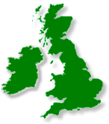
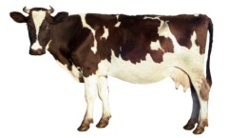
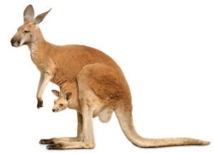
RE / PSHE | Art | Computing | PE | Music
Harvest – giving thanks to God  Belonging – what this looks like and how this feels in Christianity and Judaism | British wildlife using different media  Aboriginal art | We are photographers – taking better photographs | Sports Coach | Duration – long and short sounds

