English |  |  | Maths
Narrative  We will be reading a series of books about Emily Brown by Cressida Cowell to link with our topic on Toys. Children will then create their own short narratives focusing on common exception word spellings and forming sentences correctly. Within the unit, they will use other forms, including poetry and non-fiction.  We will also retell stories through role play and puppet shows |  |  | During this second half term we will continue to focus on number and place value, and addition and subtraction, to ensure that these concepts are fully embedded and understood. We will also focus on shape.  Number and place value –Count to twenty forwards and backwards, beginning with 0 or 1 from any given number; count, read and write numbers to 20 in numerals and words; given a number, identify one more or one less; identify and represent numbers using objects and pictorial representations including the number line, and use the language of equal to, more than, less than (fewer), most, least.  Addition and subtraction – Represent and use number bonds and related subtraction facts within 10; read, write and interpret mathematical statements involving +,-, and = signs; add and subtract one digit numbers to 10 including zero; solve one step problems that involve + and -, using concrete objects and pictorial representations and missing number problems.  Shape- Recognise and name common 2D and 3D shapes
Science | Year 2 Willow Class Topic Web  Autumn Term 2 2017 |  |  |  | History
Every day Materials  We will learn to distinguish between an object and the material from which it is made; identify and name a variety of everyday materials, including wood, plastic, glass, metal, water, and rock; describe the simple physical properties of a variety of everyday materials; compare and group together a variety of everyday materials on the basis of their simple physical properties |  |  |  |  | We will be finding out about toys from the past and present. The children will be able to describe the characteristics of toys; find out what toys our parents and grandparents played with; find out what toys were like at different times in the past; identify toys that are old and toys that are new and describe how toys are different and how they are the same.
Toys
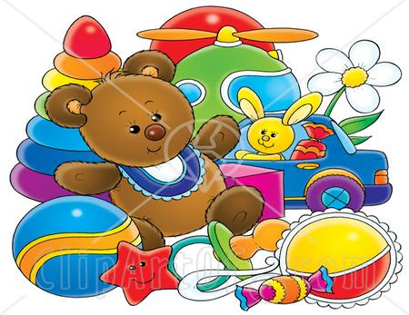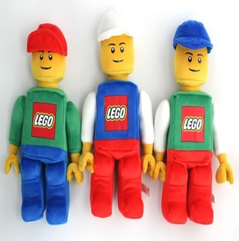
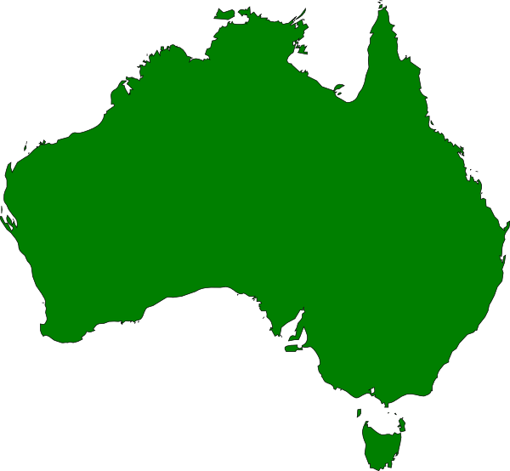
RE | Art | Computing |  | PSHE / SEAL | PE | Music
Incarnation / Celebration | Exploring and experimenting with different media to create different imaginary worlds and landscapes. | Coding – Purple Mash |  | Say No to Bullying | Sports Coach | Feel the pulse – Exploring pulse and rhythm

