English |  |  | Maths
We will be reading a selection of books about animals to link with our topic including: Rosie’s Walk, Little Red Hen, Farmer Duck, Percy the Park keeper.  Children will then create a collection of short narrative about different animals they have studied over the weeks. Within the unit, they will also use other forms, including poetry and non-fiction.  We will also retell stories through role play and puppet shows |  |  | During this first half term we will be focusing on number and place value, and addition and subtraction, to ensure that these concepts are fully embedded and understood, as these form the foundations of everything else that will be learnt in Using Dienes blocks (base ten), bead strings, place value arrow cards, place value counters, money etc, the learning objectives we will be focusing on include:  Number and place value  Counting from 1 to 100, counting in 10s from 10, matching multiples on their fingers, recognise missing numbers from a 1–20 number washing line, using knowledge of other numbers to place numbers on a line, finding amounts more, less and in between numbers,  Addition and subtraction –  partition 10 and record the related addition sentences. begin to find the related subtraction facts, relating counting on to addition, adding 2, 3 or 4 by counting on, realising that addition can be done in any order, putting the larger number first when adding 2 numbers, understanding subtraction as ‘take away’, finding one more/one less than any number up to 20 recording as number sentences, counting what’s left and record the related subtraction sentences.
Science | Year 1 Willow Class Topic Web  Autumn Term 1 2017 |  |  |  | Geography
We will be identifying and naming a variety of animals including fish, amphibians, reptiles, birds and mammals. We will describe and label the key features of these named animals, write ‘who am I?’ riddles about animals, describe a range of what animals eat and sort and group animals using similarities and differences |  |  |  |  | Compass directions  Directional and positional language  Maps  Human and physical features of the IOW and comparing them with Australia  Where people live and why (on the IOW and Australia)
Amazing Animals and Homely Habitats

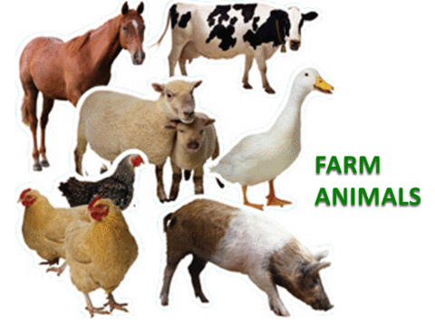
RE | Art | Computing |  | PSHE / SEAL | PE | Music
Harvest – giving thanks to God  Special places and belonging – what this looks like and how this feels in Christianity and Judaism | British wildlife using different media  Aboriginal art | We are photographers – taking better photographs |  | New beginnings | Sports Coach | Duration – long and short sounds

